**Global Waste to Energy Industry**

**Introduction**

The world generates 2.01 billion tonnes of municipal solid waste (MSW) annually, enough to fit into 822,000 Olympic sized swimming pools, with at least 33 percent of that—extremely conservatively—not managed in an environmentally safe manner. MSW comes includes trash from companies, buildings, houses, yards, and small businesses. Worldwide, waste generated per person per day averages 0.74 kilogram but ranges widely, from 0.11 to 4.54 kilograms.

The United States overall produced the most municipal solid waste of any country in the World Bank’s database. Overall, the U.S. created nearly 258 million tons of MSW per year. Daily each person in the United States creates around 2 kilograms of municipal waste.

Iceland generated around 525,000 tonnes of municipal solid waste annually. In the aggregate, that is much less than the U.S. Despite this, Iceland produced more MSW per person than the U.S. Each person in Iceland created about 4 kilograms of MSW daily.

The amount of trash is set to rise as the population grows. Between 2016 and 2050, waste is expected to increase by as much as 70 percent, according to the World Bank. When looking forward, global waste is expected to grow to 3.40 billion tonnes by 2050, more than double population growth over the same period.

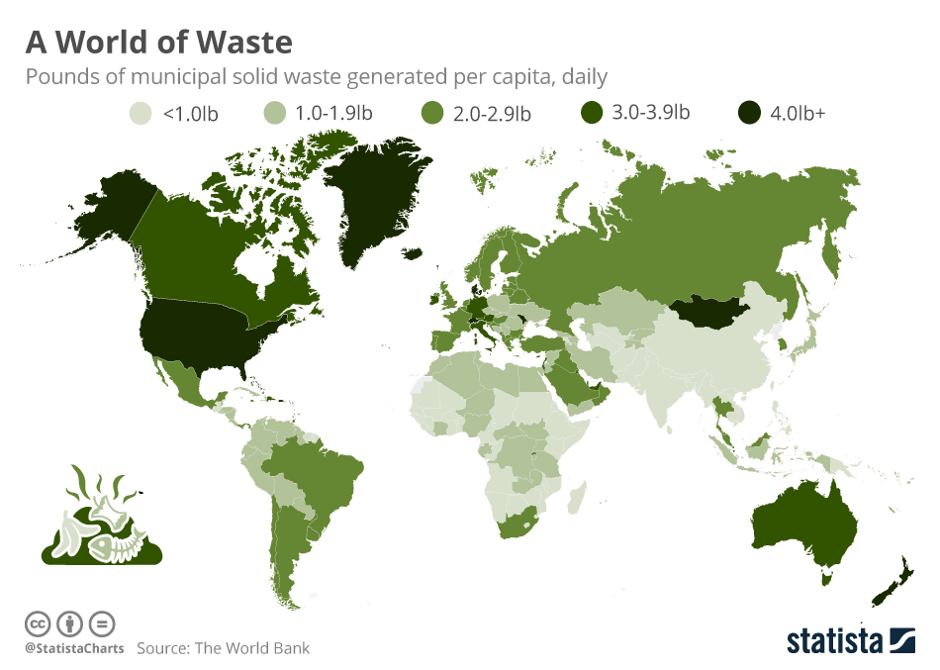

***Projected waste generation, by region (millions of tonnes/year)***

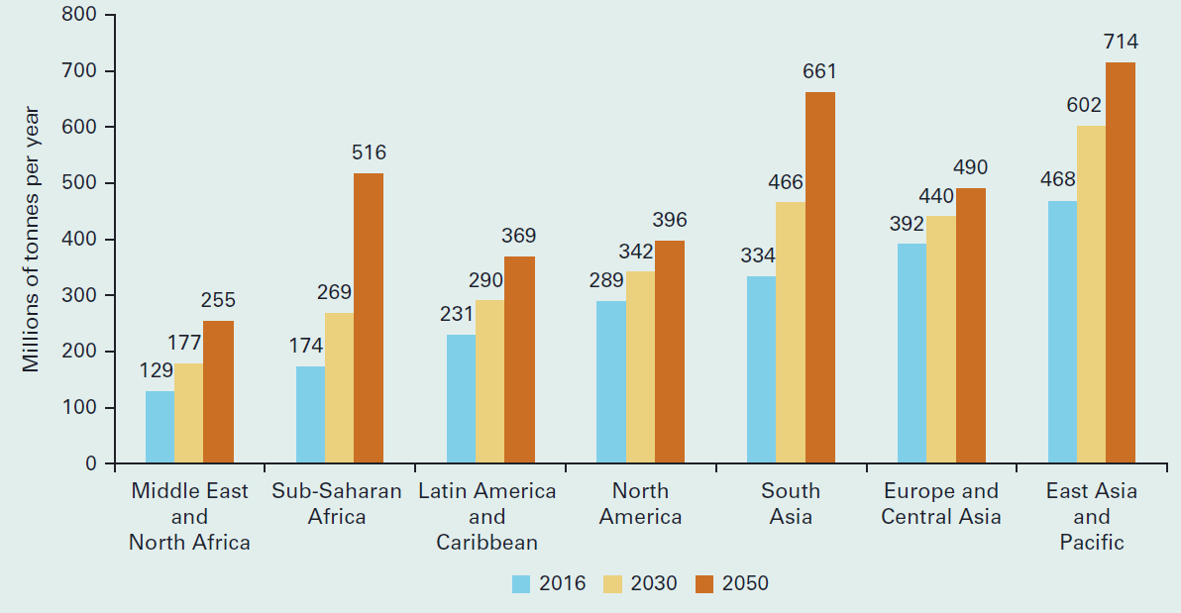

**What is Waste to Energy (WtE)?**

Waste-to-Energy (WtE) technologies consist of any waste treatment process that creates energy in the form of electricity, heat or transport fuels (e.g. diesel) from a waste source. These technologies can be applied to several types of waste: from the semi-solid (e.g. thickened sludge from effluent treatment plants) to liquid (e.g. domestic sewage) and gaseous (e.g. refinery gases) waste. However, the most common application by far is processing the Municipal Solid Waste (MSW).

The current most known WtE technology for MSW processing is **Incineration** in a combined heat and power (CHP) plant. It remains a relatively primitive energy generation technology. Waste is burned, this boils water which turns to steam, spinning turbines which create electricity. In addition, the heat from the actual combustion can be used.

Incineration is not the only waste-to-energy method, and there is an increasing number of techniques that are being implemented to make waste processing more sustainable. Some of the other notable WtE methods include:

* **Gasification:** While as a process, gasification has been used for centuries, it has only been applied to waste in a serious way in the past few decades. It works by processing biomass at extremely high temperatures without combustion, which produces combustible natural gas – also called syngas. This gas is then used as a fuel source.
* **Fermentation and distillation :** Biomass can be fermented and distilled to create ethanol. This can then be used as an alternative fuel for engines or other applications. As with other WtE methods, this can only be used for organic waste and other similar waste streams.
* **Anaerobic digestion:** This is a process in which microorganisms break down biomass in an oxygen-free environment. It produces biogas high in methane which can then be used as a fuel source to produce electricity and other applications.

**Waste to Energy (WtE) Role in Global Energy Use**

Today’s modern Waste-to-Energy facilities are designed to recover the value in the waste that remains after recycling by recovering clean energy. Waste-to-Energy facilities use state-of-the-art air pollution control equipment that scrubs and filters exhaust gases to achieve superior environmental performance, which is fully protective of human health and the environment.

Waste-to-Energy (WtE) is widely recognized as a technology that can help mitigate climate change. This is because the waste combusted at a WtE facility doesn’t generate methane, as it would at a landfill; the metals that would have been sent to the landfill are recovered for recycling instead of being thrown out; and the electricity generated offsets the greenhouse gases that would otherwise have been generated from coal and natural gas plants. WtE facilities are the only form of energy generation that actually reduces greenhouse gases.

Additionally, the energy produced at waste-to-energy facilities is reliable baseload power, meaning that it is generated 24 hours a day, seven days a week. That provides the opportunity to not only sell electricity onto the grid, but also provide steam delivered to houses, public buildings and industry.

**Waste to Energy (WtE) - Opportunities and Challenges**

WtE initiatives present several potential opportunities for project proponents and the wider community. These include an increased opportunity to extract value from waste, opportunities to reduce greenhouse emissions and reduced reliance on both fossil fuels for energy and landfills that are reaching capacity. Not only will such benefits improve amenity through reducing traffic, odour, and noise issues created by landfill, they may also alleviate the need to create additional landfill sites.

Beyond these direct benefits, WtE initiatives present a significant opportunity for investment and associated job creation, along with opportunities to redeploy waste that is problematic in landfill (e.g. agricultural waste). The potential for businesses to reduce energy costs in the face of rising gas and electricity prices through WtE initiatives is another notable advantage.

Waste-to-energy processes at specialist incineration plants can greatly reduce the volume of waste that is landfilled. According to the US Energy Information Administration, WtE plants are able to reduce the volume of waste by about 87%, burning 908 kilograms of garbage to ash weighing between 136 and 272 kilograms.

Another benefit of waste-to-energy over landfilling is the opportunity to recover valuable resources such as metals post-incineration. They can then be sent for recycling and kept in the economy. This is even true of mixed materials, which are notoriously hard to recycle. Incineration burns away materials such as plastics leaving the metals behind, which can be considered better than landfills where recyclable materials are simply buried.

While the opportunities are compelling, there are certain risks to be addressed when considering the implementation of an WtE plant.

* **High CO2 emissions :** Almost all the carbon content in the waste that is burned for WtE is emitted as carbon dioxide, which is one of the most notable greenhouse gases. That said if the waste-fuel is biomass – i.e. of natural origins, such as food waste, paper and paper board, wood, natural cloths like cotton – then the CO2 it contains was originally drawn from the atmosphere. However, plastics and other oil-based products, which are also burned in WtE, are equivalent to any other fossil fuel and emit damaging greenhouse gas emissions.
* **Potential to destroy recoverable materials :** While waste-to-energy gives the opportunity to recover some resources, such as metals, it tends to destroy far more. In the US, incineration for WtE is most commonly completed through a process called “mass-burn”, whereby MSW is burned wholesale rather than being separated. In turn, the WtE process can destroy resources that could otherwise have been recovered, including minerals, wood, plastics, and more. This is especially true if there is not a rigid separation process for municipal solid waste ahead of incineration.
* **WtE could dis-incentivize recycling :** Another of the waste-to-energy cons is the potential for it to dis-incentivize recycling or other more sustainable waste management methods. If people, organizations, or governments believe that waste-to-energy is a viable sustainable energy source and waste management technique, they are less likely to engage with or invest in more impactful solutions, such as reduction, reuse, or recycling. This can already be seen with the classification of many WtE power plants as “renewable energy”.
* **It fuels an unregulated waste trade :** Today, many developed countries send their waste to developing countries for processing, often as part of a broader waste management plan that claims to improve recycling rates. In some cases, waste is recycled, but often it is simply incinerated or used in waste-to-energy facilities.

Unfortunately, while Western countries will claim this practice as part of their recycling targets, the unregulated nature of this trade often means improper disposal, with WtE a major factor. In fact, it has even been shown that hazardous wastes not meant for incineration are commonly shipped abroad where they are burned before being landfilled.

Developing countries must stay focused on the risks and lifecycle costs of landfills and seek methods for sustainable waste management to replace current practices. Waste incineration with steam turbines and effective air pollution control systems is a technology for converting waste into clean energy, but experience shows that WtE plants are more often than not a poor economic choice for most developing countries, at least due to the high capital and operating costs (typically beyond the ability of local and national governments to finance). We probably want to avoid establishing unreasonable expectations for waste management planners in developing countries by suggesting they can go from open dumping to modern WtE in one giant step.

There are several key challenges that must be overcome to achieve sustainable development of WtE in developing countries.

* **Regulation and technical standards :** Regulations and technical standards should be established to guide and support the design and operation. The comprehensive system of regulations should cover MSW well storage at the source of generation, collection, transportation, investment, tax reduction, electricity grid connection, monitoring, and so on. The setting of technical guidelines and emission standards should consider the most advanced technologies in the world and the domestic situation of developing countries. It is reasonable to set initial WtE emission standards in developing countries at practical levels, then plan to gradually transition standards to more stringent levels as operating experience is gained over time.
* **Business model :** Based on the regulation and emission standards for WtE plants, a suitable business model is essential to attract investors. Different business models are in place in different countries and cities, including build-operate-transfer (BOT), public-private partnership (PPP) and full state-owned, with tipping fees and electricity subsidies. The business models depend on the country or city’s financial budget and the degree to which the city is willing and able to subsidize a WtE plant to ensure long-term viability. The investment cost-benefit relationship should be calculated based on local costs of materiel and labor, and a reasonable rate of return.
* **Not in My Back Yard :** Proposals to construct WtE facilities in or near residential neighbourhoods more often than not result in protracted protests by concerned citizens who are usually not fully informed about MSW management in general or WtE technology in particular. Those who embrace the “Not in My Back” Yard attitude are concerned about a range of potential negative impacts, including local and regional pollution, increased traffic, odors, decline in housing values, and stress. So, efforts for addressing “Not in My Back” focus not only on how to improve the technology and reduce emissions, but must also include a robust and long-term public information program.
* **Labour training :** The operation of a modern WtE plant is highly automatic; even artificial intelligence has started to be applied. So, labour training for the operation and maintenance is very important before construction and after routine operations begin. It is often best to form a collaborative training team comprising of both domestic and international experts with the requisite experience, e.g. involving professionals from universities, institutes, design companies and equipment manufacturers.

WtE technology has improved greatly over the past decades and will surely continue to evolve. All factors of WtE development will vary in time, such as waste composition, costs and revenue sources, technologies, so the regulations/emission standards, business model and management should be updated to lead and fit the evolving conditions.. And research will surely lead to new technologies for air pollution control, so WtE emission standards will gradually become more stringent, leading to the need to upgrade or replace older technology and plants.

**Global Market and Trends**

The waste-to-energy (WtE) market is expected to register a CAGR of 7.35% during the forecast period of 2022 – 2027, reaching a market size of USD 74 billion by 2027, up from USD 49 billion in 2020.

The global waste-to-energy (WtE) market is moderately fragmented. Some of the major players operating in this market include Mitsubishi Heavy Industries Ltd, Waste Management Inc., A2A SpA, Veolia Environnement SA, and Hitachi Zosen Corp, Covanta Holding Corporation, Veolia, China Everbright International Limited, Keppel Seghers, Abu Dhabi National Energy Company PJSC, Ramboll Group A/S.

The market growth is expected to be restrained by the expensive nature of incinerators, particularly as energy prices decline and several plants are unable to cover operating costs. Furthermore, several European and Asia-Pacific countries are planning to focus more on recycling, which saves three to five times more energy, thus, restraining the waste-to-energy market.

Thermal technology is expected to dominate the waste-to-energy market in the coming years, owing to the increasing development in incineration and gasification technologies, as well as the increasing amount of waste generated, especially from the emerging economies of Asia-Pacific.

The thermal segment occupied the largest revenue share of 82.4% in 2019, with incineration thermal technology being a major contributor to revenue growth. A relatively simple process along with ease of operations is the growth factor for thermal conversion techniques. Thermal treatment of waste serves as an environmentally sound solution for modern cities by allowing complete combustion of gases released from the waste.

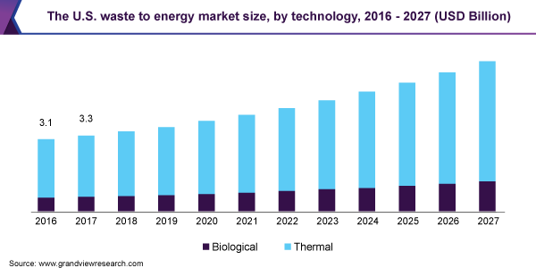

There are about 2000 WtE facilities worldwide . Asian countries (Japan, Taiwan, Singapore, and China) have the largest number of WtE facilities worldwide. All these countries face limited open space issues for the siting of landfills and high urban populations. For example, Japan has addressed its solid waste issue by processing about an estimated 70% of MSW in WtE facilities.

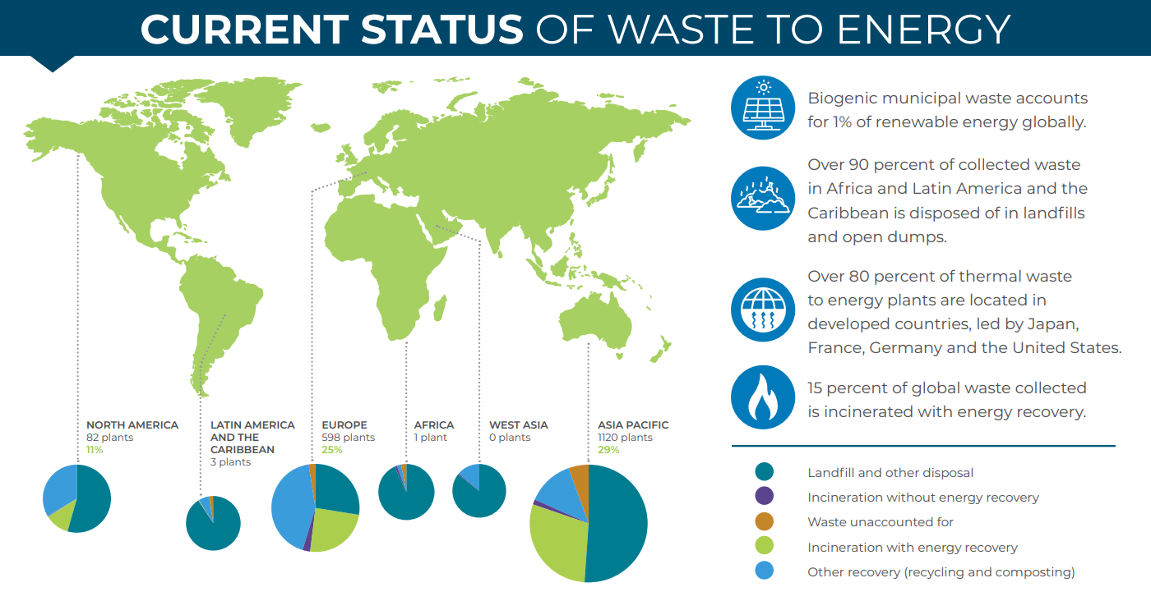

**Recent Developments and Investments in WtE Space**

Asia-Pacific dominated the market across the world, with the majority of demand coming from the countries such as China, India, and Japan. Some of the recent investments are -

* In 2022, Ram Charan -- the little-known Chennai-based chemicals trader which, of late, has been developing technologies and equipment to convert industrial and municipal waste into energy that leave no residues - is investing Rs 15,000 crore to set up two such manufacturing plants in Tamil Nadu and Gujrat.
* In December 2020, the Karnataka government laid the foundation for a waste-to-energy (WtE) plant at Bidadi, which is being developed by Karnataka Power Corporation Ltd (KPCL). The plant is expected to be operational by the end of 2022 and is set to be the first WtE plant in the state.
* January 2021, the Indian state-controlled oil firm (IOC) and North Delhi Municipal Corporation (NDMC) have joined forces in setting up a waste-to-energy plant (WtE) at NDMC’s Ranikhera, New Delhi, landfill site.
* In October 2021, the waste-to-energy plant at Kapuluppada, Andhra Pradesh, India was inaugurated. The plant capacity is around 15 MW and is expected to receive 900 to 1000 tonnes of waste on a daily basis which will be supplied by Greater Visakhapatnam Municipal Corporation.
* In December 2020, the Karnataka government laid the foundation for a waste-to-energy (WtE) plant at Bidadi, which is being developed by Karnataka Power Corporation Ltd (KPCL). The plant is expected to be operational by the end of 2022 and is set to be the first WtE plant in the state.

**Conclusion**

With countries looking to decrease their dependence on fossil fuels, there is a great potential in the renewable energy sector. While not as widely discussed as a renewable energy resource, waste to energy is considered renewable. With factors such as population growth and rising consumption levels, there is potential for the waste to energy market to increase in the next few years.

Waste to energy plants today are far more advanced than the trash incinerators of the past. Considering the innovative technology and design that is taking place in the waste management industry, it is very likely that waste to energy will become more widely utilized in the future.